**Assignment 1:**

1. Install Power BI Desktop and share the final screenshot of the report view page which appears when power desktop starts.

Answer: - Please find the screen shots of report view page of Power BI desktop below:

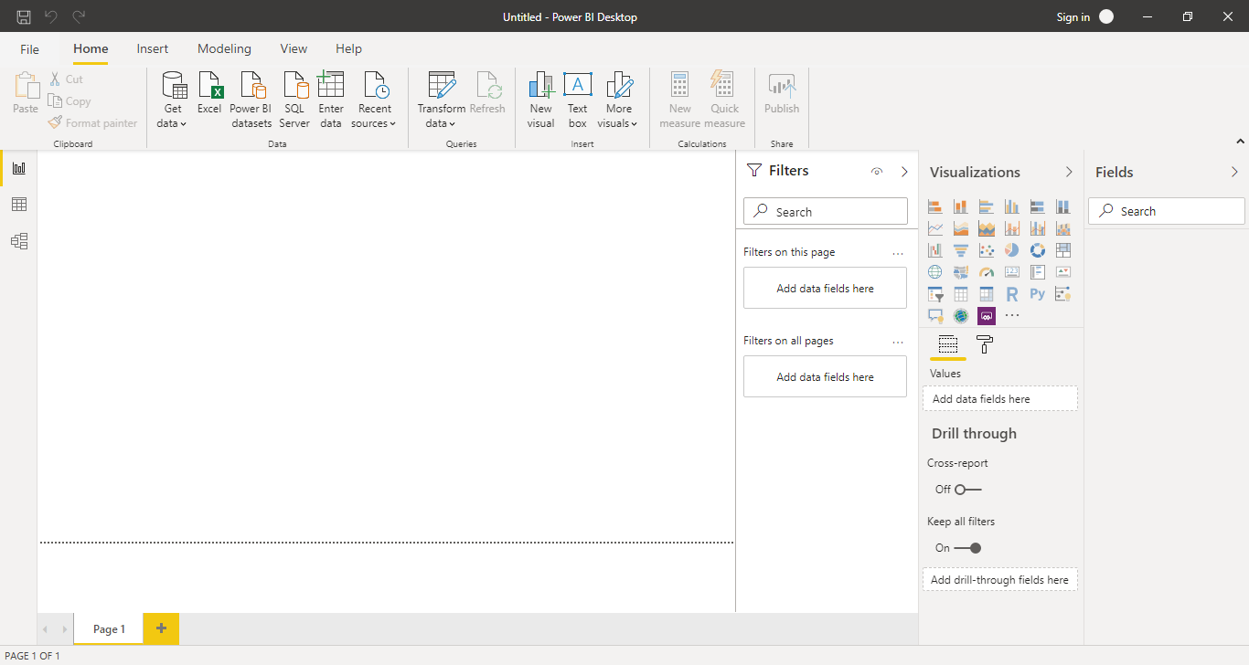

1. Prepare a document and with the following screenshot

− Report View:

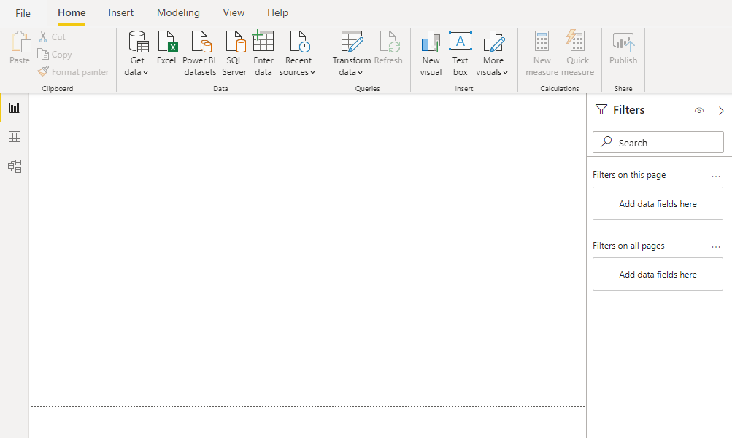

Report view in Power BI desktop is a window in power BI, where you can create any number of report pages with visualization.

− Data View:

Data view helps you inspect, explore, and understand data in your Power BI Desktop model. With Data view, you're looking at your data after it has been loaded into the model.

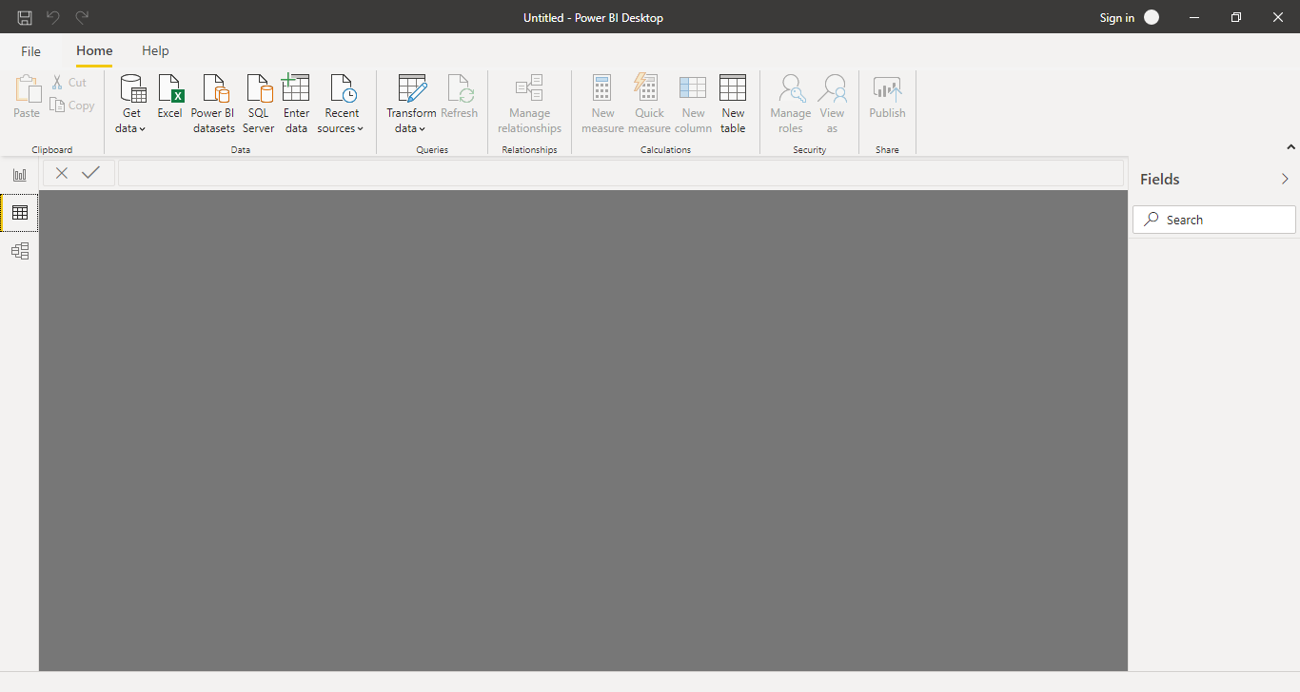

− Model View:

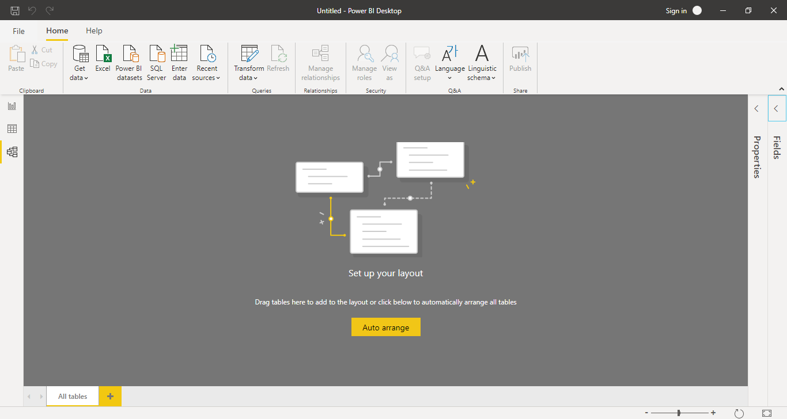

With Model view we can perform below tasks:

Break out complex models by subject area into separate diagrams.

Multiselect objects and set common properties in one go.

View and modify properties in the properties pane.

Set display folders for simplified consumption of complex models.

− Power Query Editor:

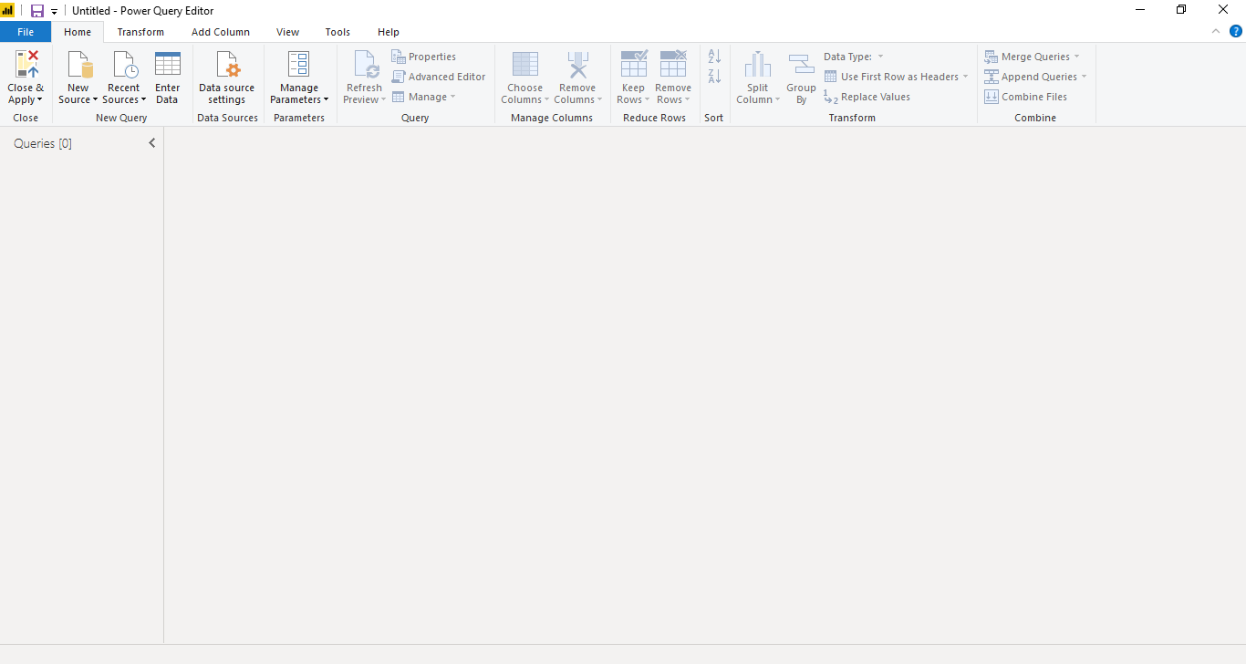

With Power Query in Power BI you can connect to many different data sources, transform the data into the shape you want, and quickly be ready to create reports and insights. When using Power BI Desktop, Power Query functionality is provided in the Power Query Editor.

− Advance Editor:

In Power BI, when we add data using Get Data button by connecting to the services, Power BI generates a query in background and we can modify this query and its data sources using 'Advanced Editor' Button.2

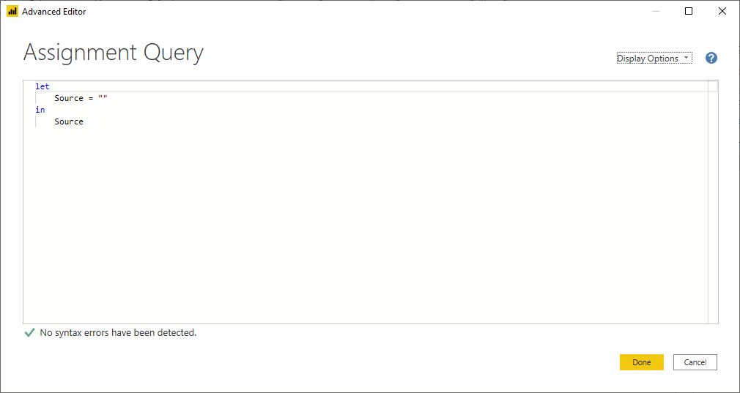

1. Prepare a document with details of the following along with their price

|  |  |  |
| --- | --- | --- |
| Product | Description | **Pricing** |
| Power BI Desktop | Monthly price per dedicated cloud compute and storage resource with annual subscription | Free Version |
| Power BI Pro | - Self-service and modern BI in the cloud  - Collaboration, publishing, sharing, and ad-hoc analysis  - Fully managed by Microsoft | $9.99 monthly price per user |
| Power BI Premium | - Enterprise BI, big data analytics, cloud and on-premises reporting  - Advanced administration and deployment controls  - Dedicated cloud compute and storage resources  - Allows any user to consume Power BI content | $4,995 Monthly price per dedicated cloud compute and storage resource with annual subscription |